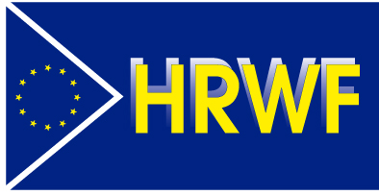

RUSSIA: Movement of anti-war activists and dissidents
is growing

With its 400 lawyers, 7000 volunteers and 190,000 private Russian donors, OVD-Info helps Russian anti-war activists, resisters, dissidents, human rights defenders, believers of all faiths…

An exclusive investigation by Human Rights Without Frontiers (HRWF: https://hrwf.eu) with OVD-Info

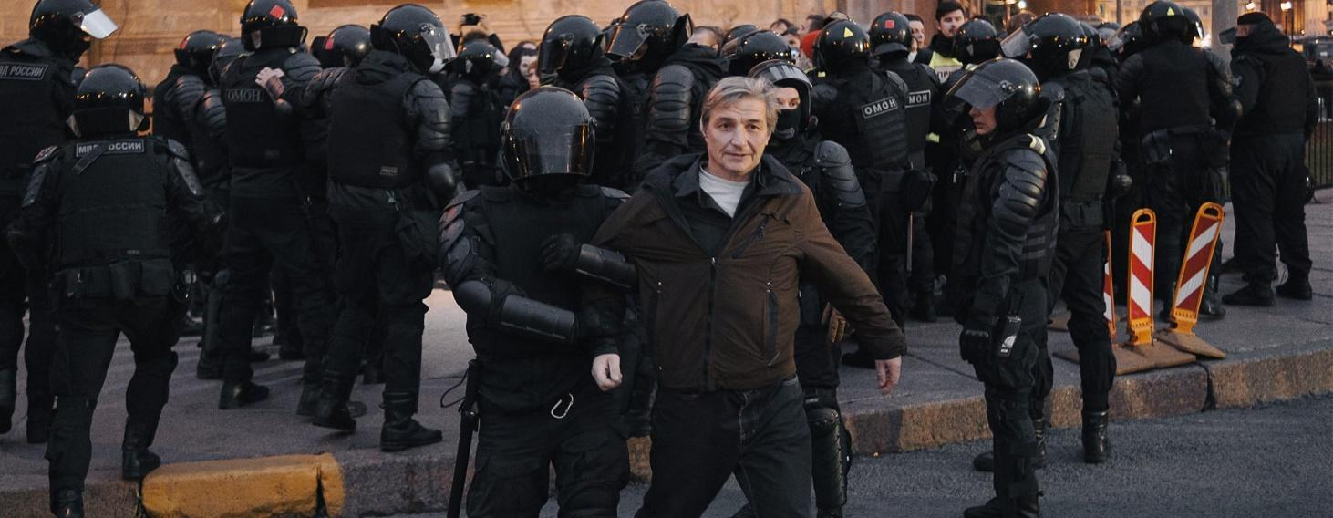Photo of one of the arrests during anti-war rallies. Source : OVD-Info website

By Dr Evgeniia Gidulianova
Human Rights Without Frontiers (HRWF), Avenue d’Auderghem 61/, B - 1040 Brussels – Website: https://hrwf.eu – Email: international.secretariat.brussels@hrwf.org
RUSSIA: Movement of anti-war activists and dissidents is growing

With its 400 lawyers, 7000 volunteers and 190,000 private Russian donors, OVD-Info helps Russian anti-war activists, dissidents, believers of all faiths. An exclusive investigation by Human Rights Without Frontiers (HRWF: https://hrwf.eu) with OVD-Info

Political analysts and commentators of Russia’s war on Ukraine in the West are almost unanimous to say that Vladimir Putin’s regime is so repressive that there is no space to think differently, to have divergent opinions and to express them openly, but is it true?

At the time of the Cold War, there were individual dissidents and collective entities of people who were thinking differently from the official political line and were fighting for the respect of human rights. A number of them were arrested and sent to the Gulag for a lot of years.

Nowadays, the term ‘dissident’ has fallen into disuse in Western narratives, and wrongly so. Not all Russians agree with Vladimir Putin but the repression is much harsher than in the 1980s and no public protest has been possible since the big demonstrations in the 2010s. However, it can be said that hundreds of thousands and even millions of Russians have dissenting opinions, do not support the war and disapprove of Vladimir Putin’s management of the country.

In October last, HRWF met, in Warsaw, Daria Korolenko, one of the participants of the OVD-Info human rights media project and the head of the data collection, research and analytics department. She was then representing OVD-Info at the (OSCE) Warsaw Conference on the Human Dimension. It is in this context that she made a challenging presentation about the way they organize collective dissidence and resistance, a movement supported by 190,000 Russian donors through their crowdfunding strategy. This allows them to pay their 400 lawyers across the whole of Russia and their permanent staff. Yes, there are many dissidents and resisters to the war in Russia…
From the very beginning, the OVD-Info project has been closely cooperating with the human rights organization Memorial, which has provided significant support and contributed to its development. In 2013, Memorial became the general partner of the human rights media project OVD-Info. At the same time, the Prosecutor's Office of the Russian Federation demanded that Memorial register as a "foreign agent" because it receives funding from abroad to support the OVD-Info project, which was regarded by the prosecutor's office as political. In early 2022, Memorial was dissolved by the Russian authorities.
Memorial is an international human rights organization, founded in Russia during the fall of the Soviet Union, to study and examine the human rights violations and other crimes committed under Joseph Stalin’s reign. Subsequently, it expanded the scope of its research to cover the entire Soviet period. Memorial is a movement which encompassed over 50 organizations in Russia and 11 in other countries.
HRWF has continued talking online with Daria Korolenko for several weeks, which has led to this interview shedding a new light on public opinion in Russia and the war.

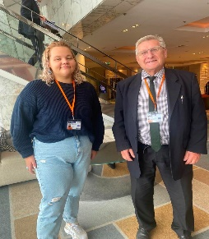
HRWF has continued talking online with Daria Korolenko for several weeks, which has led to the interview below shedding a new light on public opinion in Russia and the war.

Daria Korolenko (OVD-Info) and Willy Fautre, director of HRWF at the (OSCE) Warsaw Human Dimension Conference (HRWF Photo)

Daria, please tell us about the history of OVD-Info. How did such an unusual name come about?
OVD-Info appeared in December 2011 as a purely volunteer project when its founders, Moscow journalist Grigory Okhotin and programmer Daniil Beilinson, witnessed mass detentions of participants in a rally on 5 December 2011 against the falsification of the parliamentary elections. They began posting data on Facebook about the number of detainees, their names and places of detention. Then, on 10 December 2011, on the eve of the rally on Bolotnaya Square, they created the OVD-Info website. The name of the project comes from the abbreviation "Department of Internal Affairs" in Russian.
From the very beginning, the OVD-Info project has been closely cooperating with the human rights organization Memorial, which has provided significant support and contributed to its development. In 2013, the human rights organization Memorial became the general partner of the human rights media project OVD-Info. At the same time, the Prosecutor's Office of the Russian Federation demanded that Memorial register as a "foreign agent" because it receives funding from abroad to support the OVD-Info project, which was regarded by the prosecutor's office as political.
This cooperation with Memorial's human rights defenders is still ongoing. I am talking to human rights defenders because the human rights organization Memorial itself, along with all its regional branches, was liquidated by political decisions of Russian courts in April 2022. All of Memorial's accounts were blocked.
In the course of a multi-stage examination of the case by the courts of various instances, they pointed out that Memorial creates a false image of the USSR as a terrorist state, whitewashes and rehabilitates Nazi criminals, which of course has nothing to do with reality. Another formal reason for the liquidation was the absence of the self-identification as a foreign agent in the publications of Memorial, which was a violation of the law.
On 14 June 2022, in the aftermath of the liquidation, it was decided to create the Memorial Human Rights Protection Centre. The organization, which was created by supporters and participants of the liquidated society, continues to operate without forming a legal entity and is engaged in human rights activities in Russia and other countries.

As for OVD-Info, is the media project officially registered in Russia or somewhere else?
Our human rights media project, OVD-Info, operates without state registration. Of course, this is due to the political persecution to which Russian human rights organisations, their members and all those who cooperate with them are subjected.
In fact, we are conducting our work underground under constant pressure from the authorities.
For example, on 29 September 2021, the Russian Ministry of Justice included OVD-Info in the register of unregistered public associations performing the functions of a "foreign agent."
On 25 December 2021, Roskomnadzor blocked the OVD-Info website on the grounds that it allegedly contained "propaganda of terrorism and extremism." The agency also demanded that social networks delete the project's accounts. On the same day, Yandex removed the OVD-Info website from search results. In July 2022, the court decision to block the site was overturned. On 2 June 2023, Roskomnadzor again blocked the OVD-Info website, as well as all the websites of the media project, motivating this by "non-compliance with the law on foreign agents."
The founders of the OVD-Info media project were also persecuted by state authorities. In the summer of 2023, Grigory Okhotin and Daniil Beilinson were brought to administrative responsibility under Part 4 of Article 19.34 of the Code of Administrative Offenses for failing to mark posts on the OVD-Info page on the Odnoklassniki social network as posts of a “foreign agent.” The courts prosecuted Okhotin and Beilinson because they are listed in the Register as members of a “foreign agent.” Both were punished for not marking the same posts, but the size of the fine was different: Okhotin was fined 30,000 rubles (310 EUR), and Beilinson was fined 40,000 rubles (410 EUR).

Does OVD-Info identify itself with a human rights organization or a media outlet?
OVD-Info is a Russian non-governmental human rights media project aimed at combating political persecution. It combines human rights functions, research and journalism.
We work as a news agency, providing reliable information to both our readers and other news publications, and at the same time providing legal assistance to victims of political repression.

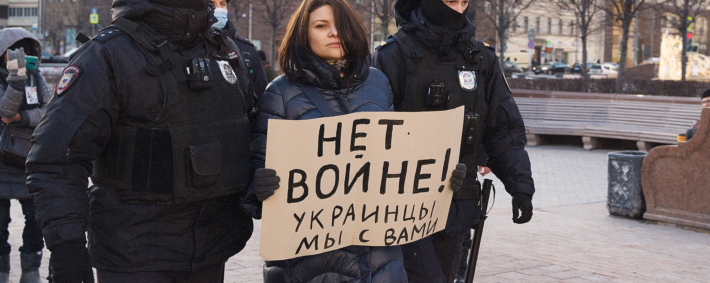Photo of an arrest at an anti-war rally. The inscription on the poster: "No to war! Ukrainians, we are with you." Source: OVD-Info website
Our media project monitors politically motivated persecutions and cases of abuse of authority by Russian police officers in relation to politically motivated detainees and political prisoners throughout Russia.
OVD-Info publishes information on its website, Telegram channel and social networks in the form of express news and stories told by the victims themselves.
Of course, such publications are carried out only with the consent of such victims, not all of whom are ready to give wide publicity to what happened to them.
Evil deeds like silence - information censorship is also preferred by law enforcement agencies. We believe that information protects, and the attention of the public and other media can prevent violations and affect the situation as a whole.
Politically motivated detentions, dismissals, interrogations, searches and arrests occur almost daily in Russia. They are faced by park defenders, truckers, deceived equity holders, anti-corruption fighters, voters, politicians, civic activists and just random people. In 2022, repression also affected people who oppose the war.
OVD-Info provides assistance to those who have been detained at a street rally, persecuted for their political views or anti-war stance. A call to OVD-Info or a message to a legal Telegram bot are the easiest ways to report the fact of harassment and consult with professionals who know what happens in such a situation, what needs to be done and what actions to refrain from.
The OVD-Info telephone hotline and the Telegram bot with built-in legal instructions work around the clock. Most of the information that is subsequently published in reports and on the OVD-Info website is received in this way.
This approach helps us to obtain unique and reliable information, which we disseminate both as a news agency for readers and as an outreach center for our global expert audience. Reliable data is at the heart of all our human rights work, and human rights violations are at the heart of our media work.
We cover political persecution in all regions of Russia. Legal advice on the hotline and in the legal Telegram bot is available to people all over the country.
Since expanding our activities in 2019, we have begun to look for lawyers for detainees outside of Moscow and St. Petersburg: we went on business trips, got acquainted with human rights communities on the ground. Now we can find and provide a lawyer in almost any region of Russia or find a friendly organization that can provide assistance.
We provide and coordinate legal assistance in cases involving restrictions on freedom of assembly and freedom of speech, including visits by OVD-Info lawyers, assistance in Russian courts in administrative and criminal cases, as well as filing complaints with the ECHR.
OVD-Info spends more than 30% of its media project on paying for the services of lawyers for victims of political repression.
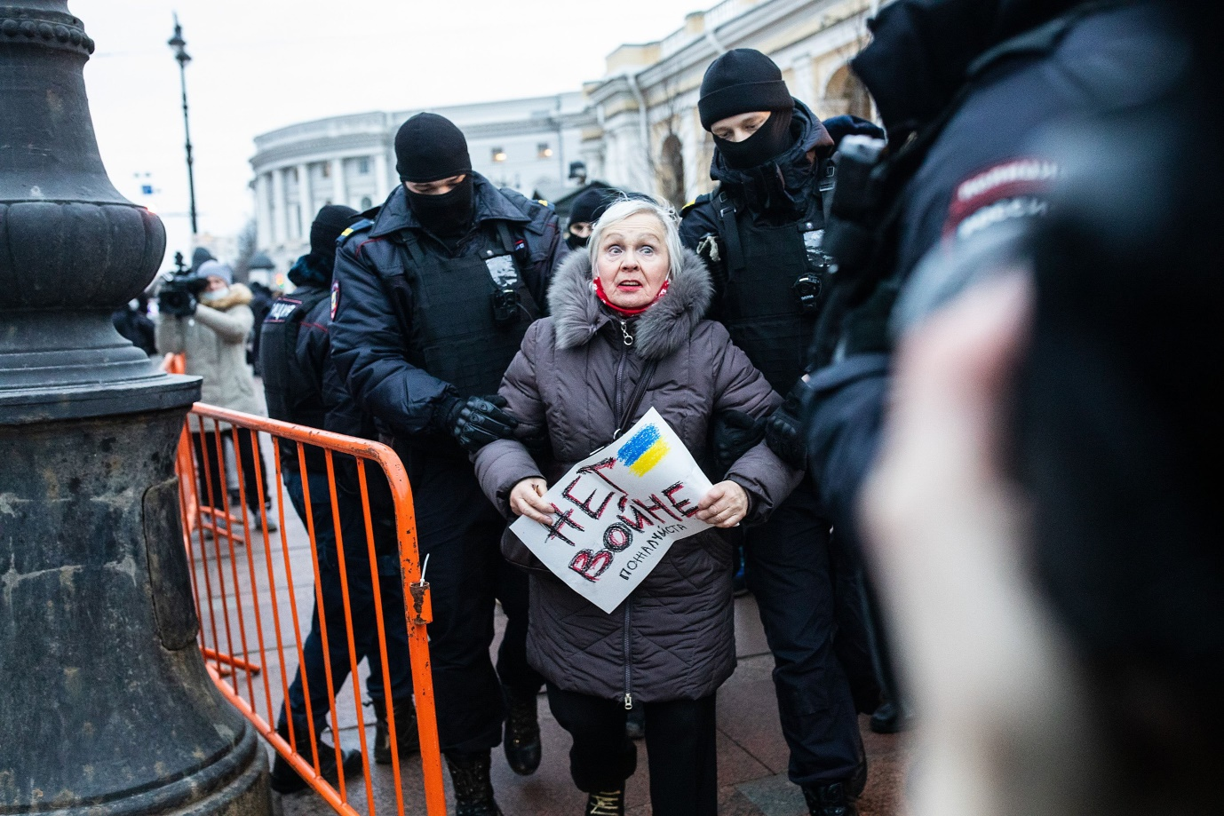
Anti-war pickets, St. Petersburg 02/24/2022. The inscription on the poster “No war please” Photo: David Frenkel “Mediazona”

The OVD-Info project conducts public campaigns. We write analytical reports and texts. We publish reports summarizing the practice of violations of the law regarding rallies and against civil society activists by the Russian authorities, reports and analytics on various aspects of repression, monthly summaries of anti-war repressions and chronicles of all political persecutions, reports for the UN and the OSCE.
We believe that the most important thing is that a person who has been subjected to political persecution should not be left alone in front of the machine of political repression.
An Internet platform called "ЗАОДНО", with which OVD-Info works closely, is another area of assistance to victims of political repression. The platform publishes the stories of people who have been politically persecuted for their civic position and tells other people about them in order to develop mutual aid mechanisms. The story of each victim is accessible. Everyone has the opportunity to make a direct donation to pay for the services of a lawyer or to pay a fine to a specific person who has been subjected to political persecution.
Due to limited resources, OVD-Info currently provides assistance in providing legal counsel only to those who have been subjected to administrative or criminal prosecution as a result of expressing their anti-war position or because of the exercise of their right to freedom of assembly.
In 2022, OVD-Info and the Media Defense Center launched the Inoteka project to provide legal assistance to individuals and organizations listed as "foreign agents."

Daria, according to the OVD-Info database, how many people in Russia have been subjected to political persecution in recent years? How many people have been prosecuted? How many political prisoners are in Russian prisons today?
We have been tracking politically motivated criminal prosecutions since 2012. In total, at least 3 415 people have been subjected to politically motivated criminal prosecution since then. At least 997 of them are currently in places of deprivation of liberty (in a colony, in a pre-trial detention center awaiting sentencing, or under house arrest). A huge part of the criminal political prosecutions dates back to recent years. At the beginning of 2022, at least 1 607 people were prosecuted for political reasons.

According to our data, during the twenty months of the war in Ukraine, their number reached 19,810 people detained at anti-war rallies, and 772 defendants in criminal cases, including minors and pensioners. And their number continues to grow. In the new summary we continue to collect and analyze data on political and anti-war repression in Russia. (*)

How does OVD-Info operate and how is it funded?
OVD-Info is an independent project fighting for human rights and against repression in Russia. Founded in 2011 in Moscow, as of 2023 it is one of the largest Russian independent projects working on the ground, with the participation of about 400 lawyers, 7000 volunteers and 190,000 private donors. Today, OVD-Info is one of the most authoritative sources of information on human rights in Russia, which is widely and regularly used by the international media to cover topical issues.
In the aftermath of Putin's full-scale invasion of Ukraine, which sparked a wave of mass repression within the country, the most valuable part of our work is supporting the anti-war movement, both through media coverage of the protests and by providing legal assistance to activists participating in public rallies and other anti-war events. The information that OVD-Info collects and disseminates on an hourly basis is the most reliable source of information about what is happening inside Russian civil society, both for domestic and foreign audiences. This information helps stakeholders shape a global response to the Kremlin's war on Russian civil society.
We do not support any particular interest groups and protect people regardless of their and our policies.
We don't censor, but our commitment to human rights is first and foremost our publication: we don't publish information if we think it could cause harm.
OVD-Info covers political persecution in all regions of Russia, covering 11 time zones and extremely diverse populations throughout the country, 24 hours a day.
Our Legal Advice Hotline and Telegram Bot are available at any time throughout the country. Such a schedule of work is due to the complexity of the political situation in Russia, in which all dissidents are in constant danger of persecution, and therefore the participants of OVD-Info must always be constantly ready to provide maximum assistance, including, if necessary, legal assistance.
We develop services that help you be proactive, including a legal Telegram bot with built-in legal instructions, a generator of court petitions or complaints to the ECHR for facilitating the preparation and submission of documents.
The main source of funding for the OVD-Info media project is crowdfunding.
On a monthly basis, we publish detailed reports on our activities, financing and expenditure on our website.

What are the final goals of OVD-Info in its activities?
OVD-Info considers its goal to be a complete cessation of persecution for political reasons in Russia.
Our project is aimed at the development of civil society institutions and mechanisms of public control of the authorities and law enforcement agencies in Russia. We believe that freedom of assembly and expression are inalienable rights of every person.
OVD-Info is politically neutral and protects people of all views.
We believe that it is important to protect freedom of assembly, and not only by helping people who have been repressed. Legal action to bring about change in this area is equally important to us, in particular the accountability of the authorities and their compliance with laws and regulations. To this end, we initiate lawsuits, petitions, complaints, applications and appeals regarding illegal acts or omissions of officials when they violate the right to freedom of assembly or the law in the context of public events. We are also in favor of more active protection of this right for all Russians.
In the past, we launched the largest petition on the Russian website Change.org, successfully lobbied for the creation of a UN mandate for a special rapporteur to monitor human rights in Russia.
We study the problem from different angles – this helps both to develop tactical solutions for today and to lay the foundations for changes to the system in the future.
We believe and hope that changes will take place in Russia and it will be able to become a state governed by the rule of law with priorities for the protection of human and civil rights and freedoms.

Footnote

(*) When including data in our database of criminal political prosecutions , we proceed both from several systems of assessments. One is developed by OVD-Info according to the criterion of "political motivation." Others are developed by other human rights and research organizations, including the Memorial Human Rights Center / Project "Support for Political Prisoners. Memorial" and the SOVA Center for Information and Analysis/SOVA Research Center. When making a decision to recognize a person as a political prisoner or (less often) persecuted for political reasons without deprivation of liberty, we are primarily guided by the Methodological Recommendations on the Definition of the Concept of a Political Prisoner, developed by human rights defenders from different countries on the basis of Resolution of the Parliamentary Assembly of the Council of Europe (PACE) No. 1900 (2012).

Each row of the table in the database of political persecution is devoted to the prosecution of a certain person within the framework of a specific criminal case. This data was collected and evaluated through the work of OVD-Info, Memorial and SOVA.

Since the beginning of the full-scale invasion of Ukraine, the main figure has concerned political repression against opponents of the war who participated in anti-war rallies.

For more information, write to Human Rights Without Frontiers (Brussels) international.secretariat.brussels@hrwf.org

