Moldova Between Aggression and Accommodation

A brief report by the Forum for Religious Freedom-Europe (FOREF) and Human Rights Without Frontiers (HRWF) based on a fact-finding mission in Moldova in mid-May 2022

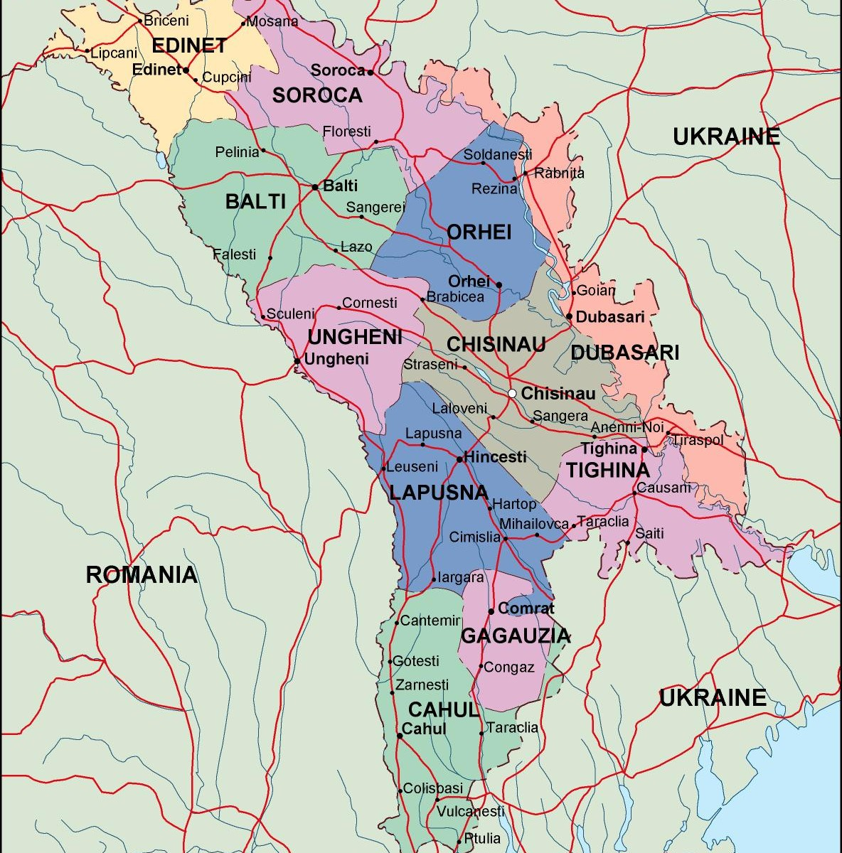
Introduction

The security and human rights situation on the Republic of Moldova has come into closer international focus in the course of Russia’s invasion of Ukraine in February 2022. Tensions and speculations spiked after a series of explosions in April, in Moldova’s unrecognized breakaway region of Transnistria, which borders Ukraine, and where Russian troops have been garrisoned for 30 years. The explosions followed a warning by a senior Russian military commander about alleged oppression of Russian-speakers in Moldova, arousing speculation that Russia might open up a second front, and even invade Moldova, a country with virtually no military capacity, on the same pretext as deployed in Ukraine. Like Ukraine, Moldova is seen by Russian political figures and thought influencers as lacking any historical claim to sovereignty, and as a prospective part of a renewed Russian (Nova Russia) sphere of influence. Like Ukraine, Moldova’s right to autonomy and self-determination, and the political agency of its citizens, are sometimes ignored in Western strategic thinking. Indeed, the small state on the eastern edge of the European Union is seen as a buffer between Europe and Russia, as determined by the putative laws of realpolitik.

Dr. Aaron Rhodes of the Forum for Religious Freedom-Europe ( FOREF ) and Hans Noot, MOB, of Human Rights Without Frontiers ( HRWF ) went to Moldova in May 2022, to speak with civil society experts about the dangers facing Moldova, and about perspectives important to Western governments if they are to responsibly support citizens’ aspirations for freedom and democracy in the country.

Post-Soviet Moldova
Established as the Principality of Moldova in 1350, over the centuries its borders have been moved back and forth, and portions of the nation were either under control of the Ottoman Empire, the Soviet Union, Ukraine, or Greater Romania. Moldova came under Soviet power in 1940-41, but was conquered by Nazi-allied Romania, with its Jewish population devastated by deportations and executions. After World War II, Moldova was joined to a segment of a previously Ukrainian region, the Moldavian Autonomous Soviet Socialist Republic, on the left bank of the Dniester River (Moldovan: Nistru) as the Moldavian Soviet Socialist Republic. Upon the break- up of the Soviet Union in August 1991, it declared its independence, naming itself the Republic of Moldova. By then the nation had been split into portions of New-Bessarabia, while southern Bujak was put under Ukraine. During that same time Gaguazia and Transnistria declared independence from Moldova. However, this move has, to date, been unrecognized by the international community. Resolving the conflict between Moldova and Transnistria is one the European Union’s requirements for joining the EU.

Although Moldova joined the United Nations as a neutral state, one would expect it would not allow foreign military troops be stationed on its territory. However, Russia has to date not complied with this proposition, as in Transnistria there are Russian troops, as well as an ammunition depot with an estimated two hundred thousand tons of ammunition. Consequentially, the permanent neutrality of the Republic of Moldova is not guaranteed at the international level. From Russian side, the situation is comparable to that of Finland during the Cold War. It is seen by the Kremlin as an “external dependence on Russia”.

Given its history of changing allegiances and the Russian Federation’s support for separatists in Transnistria, Moldovan leaders have assumed a nuanced policy of neutrality. A year after he had called for the withdrawal of Russian troops in Transnistria, for example, former Moldovan President Igor Dodon expressed how the country disavowed sponsorship to the United Nations General Assembly. At the same time, he sought a political solution with Russia to the Transnistria conflict, and to define a policy leading to stability and security given alleged great-power rivalries over Moldova.

Moldova is the poorest nation in Europe and plagued with demographic decline and corruption. But

- with the Russian Federation having invaded Ukraine with the intention of bringing it within a revanchist Russian sphere of influence by force,
- with Russian troops and huge ammunition depots still on Moldovan territory in the occupied Transnistria after 30 years,
- with nominally pro-Russian political parties occupying half the seats in Moldova’s parliament,
- with Russian media and propaganda exerting major influences on public knowledge and opinion,
Moldova’s position, and the aspirations of citizens for human rights and democracy, are considered “fragile,” threatened by both the possible renewed Russian military aggression, and by accommodationist inclinations that would leave the country as a buffer state and trading zone.

Transnistria: Moldova’s 30-year-old “silent war”
Moldovans today well understand the trauma felt by their neighbors in Ukraine. Experts told FOREF/HRWF that while Ukraine has suffered Russian aggression since 2014, Moldova’s experience with the phenomenon has extended over a 30-year in what they called a “silent war,” during which Russian military occupation has continued in Transnistria, and Russian political influence has persisted in the country. Asked if Moldovans feared invasion by Russia, respondents said, “Russia has already invaded Moldova.”

Since July 1992, following armed conflict taking place beginning March of that year with separatist forces that claimed about 700 lives, Moldovan authorities have exercised no effective control over Transnistria, the self-proclaimed “Pridnestrovian Moldavian Republic” that comprises 12 percent of Moldovan territory. The division has not led to significant animosity between the two civilian populations. But the geographical, political, and social fracture of Moldova, and the malign role played by Russian and Russian-backed authorities vis a vis Transnistria are clearly central factors associated with most of Moldova’s major problems.

Transnistria is, of course, among the “frozen conflicts” of the post-Soviet space and has been recognized only by other breakaway entities of South Ossetia, Artsakh and Abkhazia. It is a presidential republic where some degree of political competition exists, yet without democratic safeguards of elections or minority rights.

FOREF/HRWF were informed that leaders are “waiting for instructions” in the current situation. Transnistria’s political authorities actually share de facto power and influence with powerful business interests (“oligarchs”) as well as Russian authorities. Among these are Victor Gushan and Illya Kazmaly, former Russian special service agents who control the Sheriff company, based in Tiraspol, which, informants say, exercises control over policies of the state apparatus. Some interlocutors urged that solving the problem of Transnistria would be advanced by the West imposing sanctions on these influential “oligarchs” from the region.

Transnistria’s Retrograde Human Rights Practices
Transnistria is home to about 350,000, although authorities claim significantly more. While more than 90 percent are Moldovan citizens, they are denied the political and civil rights guaranteed them under the Moldovan Constitution and by the European Convention on Human Rights. They live marooned in a grey zone, their choices limited by Russian manipulation, local autocrats, and powerful oligarchs.

Human rights organizations have documented infringements of
- the right to freedom of expression, the press, association, assembly and movement,
- the right to citizenship,
- the right to an adequate standard of living,
- the right to property,
- and the right to health and education,
- as well as numerous cases of arbitrary detention, torture and ill-treatment by the police as well as overcrowded and unhealthy detention conditions.

Moldovan and international human rights organizations have brought numerous cases of violations of the rights of Transnistrian residents to the European Court. These have included, for example, cases concerning Transnistria’s prohibition of the use of Moldova’s Latin script. Organizations have been illegally shut down because of the use of the Romanian language. Other cases have been brought on behalf of those who have been tortured in the penal system. The Russian state, as party to the European Convention exercising effective control over the actual political authority in Transnistria, have been held accountable for these violations. The human rights situation in Transnistria has always been among the worst in the Council of Europe region, with conditions that, like the political orientation of its rulers, resemble those in the Soviet Union. Dissent is harshly punished. In recent months, as the war in Ukraine has increased tensions, human rights violations have reportedly become more severe. New legislation has been adopted that makes it a crime to file complaints to international authorities, punishable by a 10-year prison sentence.

Negative Influences on Moldova’s Political and Economic Development from Transnistria and Russia
Moldova’s continuing failure to gain control of its territory, and protect the rights of all its citizens, is the main obstacle to its political and economic development.

Politics and political freedoms
Moldova’s current government is pro-European – promoting European political and economic standards, and seeking EU membership. It shares its language and culture with Romania, to which it also has strong economic ties.
Political parties are divided evenly between “left” and “right,” but these categories do not refer to economic policies: Right-wing parties are pro-EU, and left-wing are pro-Russian. This equal political divide creates a stalemate that results in the parties focusing mostly on detailed policies, rather than governing a nation with a long-term strategy as regards foreign policy, social and economic issues, environmental challenges, etc.
The existence of a separatist, Russian-backed political entity promotes further division in the country, through proxy-politicians, funded by Russia, who propagate Russian narratives. “They are not uniting the people, but push for division,” the FOREF/HRWF representatives were told.
In the current situation, the problem of Transnistria, while a greater strategic obstacle than ever, is on the back burner.

Religion and political orientations
Ninety-one percent (91%) of Moldovan citizens follow the Moldovan Orthodox Church (MOC), which answers to the Moscow Patriarchate. The Bessarabian Orthodox Church (BOC), which is subordinate to the Romanian Orthodox Church, is followed by 3.7% of the population. The MOC has always promoted policies of the Russian Federation and pro-Russian political figures; Maia Sandu won the 2020 presidential election despite the MOC’s support for re-election of pro-Russian incumbent Igor Dodon, who claimed to have been told by Russian Orthodox Patriarch Kirill that his mandate was willed by God. Minority religious groups have reported that the MOC has contributed to discrimination against them.
Many priests do not accept Russian narratives and interference, many others do. But in the North, church leaders challenged a law banning the use of the Russian “Z” and “V” war symbols of war can be used.

Media
Freedom of the press, the right to information and freedom of speech are protected by law and generally respected by authorities, according to independent observers. Moldovan authorities do not seriously restrict the freedom of speech and media freedoms; Reporters Without Borders ranked Moldova at 40 out of 180. But major media are politicized and lack objectivity. According to Reporters Without Borders “Moldova’s media are divided into pro-Russian and pro-Western camps. Oligarchs and political leaders strongly influence their editorial stances.” The media empire built by former billionaire and "Democratic Party of Moldova" chairman Vladimir Plahotniuc is prominent. The pro-Russian outlets (Primul TV and Accent TV, NTV and RTR Moldova Russian government or Gazprom funded) are influential. Pro-government media and the rest of media promote political preferences. There are some commercial and external donor-funded outlets operating.
As of 2013, more than twenty Russian channels transmit in Moldova. Since the invasion of Ukraine by the Russian Federation, the government drafted a “mis-information act” aimed at reducing propaganda. An interlocutor said, "We are victims of the same propaganda as in Russia."

Economy
Moldova is the poorest nation in Europe and plagued with demographic decline and corruption. But Moldova is also a post-Soviet society where commitment to democracy, and respect for human rights, does show signs of growth.
Moldova’s fractured politics and disinformation are the main problem depressing its economy. The major obstacle to foreign investment in Moldova is the unresolved problem of Transnistria, which is considered to make the country politically unstable.
Even though most Moldovan exports, including from Transnistria go to Europe (60% - dominated by Romanian market) compared to only 9% to Russia, underlying production factors (energy, banking) are dependent, and to a large degree, controlled by Russia, and thus subject to violent fluctuations, amplified from Russia’s invasion of Ukraine. Moldova is 100% dependent on Russian gas supplied by Gazprom and distributed by Gazprom. In one month, the price rose by 400%, and over the course of the crisis the price has increased by 800%. An average household must pay 50% of its income on utilities. Moldova’s inflation rate in 2022 is the highest in Europe -- between 25% and 27% as of this writing.

Moldova’s main export is wine; the country has around 80 distilleries. Cereals, fruits and vegetables are also produced and exported, but agriculture is inefficient and uncompetitive; consequently, much of the country’s agricultural requirements are imported. No more than 29% of Moldovan exports goes to the EU. Under Soviet control, heavy industries were located in the Transnistria region. Transnistria exports more goods to Romania than to Russia, but imports more from Russia. It is estimated that 70% of Transnistrian trade is with the EU, all of which comes through Moldova.
The average wage per month in Moldova is a mere € 482 or $509 per month. For those outside Chisinau, 30 or 40 Euros per month is the norm; there is hardly any middle-class. At the same time, the cost of many consumer goods is often comparable to that in European Union member states.

Corruption
The problem of corruption in Moldova cannot be separated from the country’s political polarization, and negative Russian influences. Major corruption in the banking sphere, and specifically the so-called ‘Russian Laundromat’ scheme allowing for large sums of money (some 20 billions) to be moved from Russia (allegedly Russian state resources) to Western European banks via Moldovan banks. Moldovan politics are still reeling from the theft in 2014 of more than one billion US dollars, equal to 12% of the nation’s GDP.

The scandal led to anti-corruption protests on the streets. Major corruption cases emanate from Russian gas and energy production and distribution as well as the use of state funds for procurements. The political movement that eventually led to the election of the current government was formed to address these issues.

A new form of governance has been promised, with transparency as one of the major strategies towards qualifying for EU membership status. In October 2021 the top prosecutor, General Prosecutor Alexandru Stoianoglo” was suspended and detained on charges of corruption. Justice Minister Serdgiu Litvinenco on Tuesday accused Stoianoglo of being a "puppet in the hands of large corrupt officials and thieves who have been robbing Moldova for decades". Petty corruption, too, is widespread in the health, education, social, tax and property rights areas.

Demographics
Moldova’s political fracture exacerbates a demographic decline that threatens the country’s future. The fertility rate is only 1.3 children per woman. There are an estimated 800,000 pensioners, more than 50% of the population. With opportunities limited by economic stagnation, which is in turn the result of a lack of foreign investment, young people, who might provide labor for an economic rejuvenation, are leaving the country for opportunities abroad.

Refugees
450.000 Ukrainian refugees have crossed into Moldova. Only 100.000 remain, with 90% hosted in private households, of which 50% are children. The United Nations and private donors are assisting Moldova with their support, and many have been taken in by local families, especially in northern Moldova where the population includes many Ukrainians. Most refugees travel on towards the West. The Moldovan government does not see refugees as an opportunity to increase the labor force.

Transnistria’s Security Threat to Moldova, Ukraine, and Europe
Transnistria is at once a source of Russian influence, a hub for corruption, and a Russian military base and arms depot. There are an estimated 2,000 Russian forces on the ground in Transnistria, according to public sources, and 15,000 troops in the armed formations of unrecognized Transnistrian authority. The Cobasna ammunition depot is one of the largest in Europe, and located only two kilometers from the Ukrainian border. It has been said that an explosion of the ordinance located at Cobasna would be equivalent to that at Hiroshima.

The existence of Russian military forces in Transnistria seriously compromises Moldova’s security. While Moldova is vulnerable to invasion by the Russian Federation, these elements factor into both Russian and Ukrainian strategic plans, raising the fundamental problem of where the Moldovan people, and their government, stand in the geo-political confrontation that is the war for Ukraine.

Moldovan military assets

According to information received by FOREF/HRWF, Moldova’s military capacity is smaller than the forces assembled in the Transnistrian region. It includes small numbers of Soviet era armoured vehicles, artillery pieces and mortars. Ground forces consist of 3 brigades and 2 battalions, as well as a special forces detachment. The Moldavian Air Force is limited to a staff of 826 people. The Air Force includes several fixed wing aircraft and 17 helicopters, and MiG-29 fighters, which are not combat-ready. Several thousand Carabinieri troops are subordinate to the Ministry of the Interior, charged with keeping public order.

Moldovan regions especially vulnerable to a Russian/Transnistrian incursion
Moldovan analysts believe the Russian Federation may consider deploying forces based in Transnistria to conduct military operations in Ukrainian Budzhak with the involvement of military formations from the Transnistrian region. The rational for these actions would be the diversion of Ukrainian military forces from efforts to liberate the Kherson direction, and to protect Odessa. They could function to help the Russian Federation establish a land bridge to Transnistria.

The region of Moldova most vulnerable to Russian attack is the Moldovan Budzhak region (Gagauzia, Taraclia), which is located only 100 km from the administrative borders of Transnistria through the Caushan and Cimisli regions. Gagauzia and Taraclia, with a combined population of about 100,000 is openly pro-Russian and has a history of opposition to Moldovan authorities. Some residents have reportedly participated in aggression in the Donbass.

The defence of Odessa is clearly key to defending Moldova.

Conclusions
With the election of a pro-Western government after successive pro-Russian regimes, Moldova’s leaders today struggle to cleave to Europe, yet retain neutrality, in what may be an untenable balancing act. Moldova joined the United Nations in 1992. But today, the mission found, open political discourse about the moral and political choices facing Moldova is discouraged, in an effort to evade pressures to support Ukraine’s war of resistance. A palpable tendency of denial and accommodation is unsatisfactory, especially to Moldovans who see their freedom and security as depending on an uncompromising commitment to human rights and democracy.

Our organizations focus on defending basic individual freedoms, democracy, and the rule of law. We fear that in the present situation, these principles, the honoring of which is essential to the people of Moldova no less than to people everywhere, may be neglected by Moldovan leaders and European partners in an effort to retain the country as an economic and political buffer state. Maintaining Moldova as a neutral trading platform, which would be favorable to economic strategies of both Europe and Russia, would mean accepting the existence of Transnistria as a lawless, Russian-supported enclave where Moldovan citizens are denied basic human rights. We cannot accept policies that trade human rights for short term economic benefits of Europe.

In the current situation, ending the Russian occupation of Moldovan territory, which is the main obstacle to social and economic development of the country should be the top priority of the Moldovan state and its friends in the West.

https://h1.md/en/neutrality-of-the-republic-of-moldova-from-transnistrization-to-finlandization/
Eurasia Daily Monitor Volume: 16 Issue: 134, By: Vladimir Socor https://jamestown.org/program/president-dodon-introduces-nuances-to-moldovas-neutrality/
2018 UN General Assembly Adopts Texts Urging Troop Withdraw from Republic of Moldova, Strengthening Cooperation in Central Asia | Meetings Coverage and Press Releases (un.org), 2022 PACE CoE recognition of Transnistria occupation by Russian Federation doc.+15477.pdf (ecoi.net), The 1999 OSCE Istanbul Summit Decisions on Moldova and Georgia: Prospects for Implementation (ethz.ch)
Russia is effectively controlling Transnistria, Case of Ilascu and others v. Moldova and Russia, https://hudoc.echr.coe.int/eng#{%22itemid%22:[%22001-61886%22]}
See Human Rights in the Transnistrian Region, Joint Submission of Promo-LEX Association and the International Federation for Human Rights (FIDH), UN UPR 40th Session (2022)
https://www.moldova.org/en/transnistria-exports-goods-romania-russia/
https://tradingeconomics.com/moldova/wages
CCPR: The impact of corruption on the fulfilment of human rights in Moldova: An analytical study with policy recommendations, https://www.undp.org/moldova/publications/impact-corruption-fulfilment-human-rights-moldova-analytical-study-policy-recommendations. With a deeply rooted tradition of corruption, Moldova will need time to recover.
https://en.wikipedia.org/wiki/Russian_military_presence_in_Transnistria

